TASK 2
Practice task

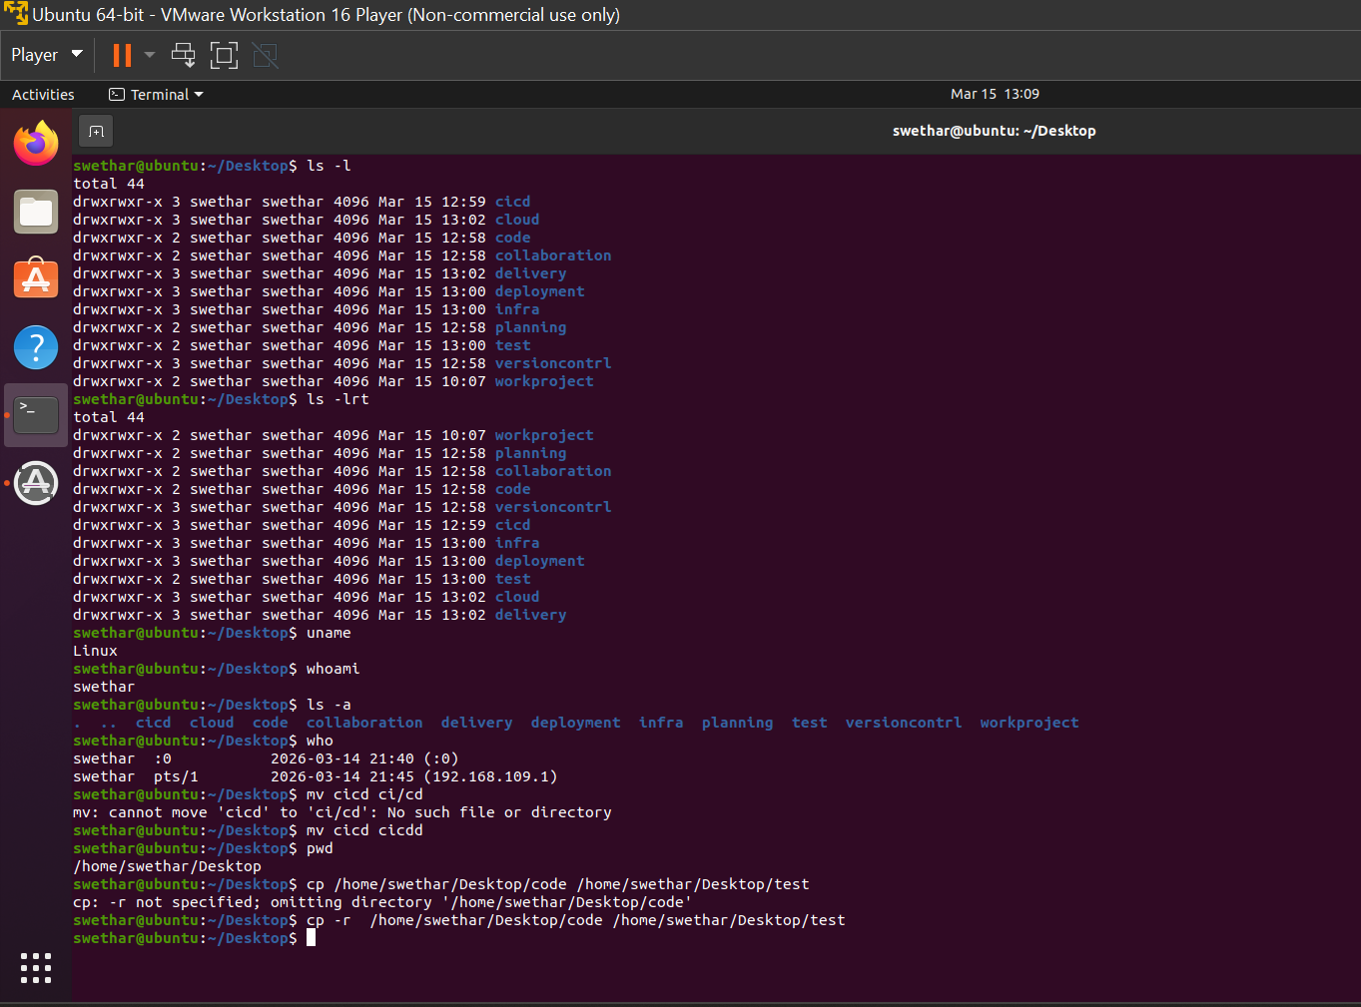

Additional task
1.How do you copy multiple files at once from one location to another location?
2. What happens if the destination file already exists while copying a file ?
3. How do you move all .txt files to another directory?
